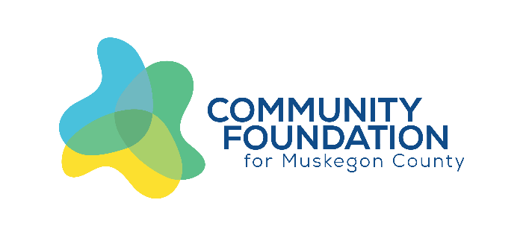

Strategic Leadership Grants: A Call for Proposals
The Community Foundation’s vision to build a vibrant community with great opportunities for all serves as the basis for our values: hope and opportunity, particularly for youth; collaborative community goals and decision making; and an inclusive community.
This vision was reaffirmed in August 2019, and again in 2022, when the Community Foundation underwent a strategic planning process to guide where we could make the largest impact with our investments of grant dollars, community engagement, and advocacy. The process involved surveying our stakeholders, community leaders, donors, trustees, volunteers, and staff to determine the areas of focus. The planning process resulted in three strategic goals:

Advancing Educational Attainment (Education):
- Lifelong literacy, including STEAM (science, technology, engineering, arts, and mathematics) and financial literacy
- Educational equity (opportunities for every student to achieve their full potential)

Fostering a Dynamic, Local Economy (Community and Economic Development):
- Workforce supports including affordable daycare, housing, and job training, and access to skilled trades
- Business supports such as entrepreneurship, development, and capacity of local community and economic development partners

Enhancing Community Trust and Promoting Prosperity for All (Diversity, Equity, and Inclusion):
- Cultural competency
- Community outreach, including courageous conversation
- Promote spaces where all voices are valued

Who can apply: Grant requests must be initiated by non-profit organizations, including schools, governmental units, and faith-based organizations.

How much is available: Up to $200,000 will be granted over the next year. We envision multiple grants will be supported at ranges of $5,000-$50,000. Multiyear requests, with phased-out funding over three years, will be considered.

Priority will be given to projects that:
- Create local teams and partnerships and utilize grassroots efforts to increase collaboration
- Demonstrate in-kind and financial support from other sources
- Utilize existing community assets
- Have potential to continue beyond the life of the grant

Strategic Leadership Grants: A Call for Proposals

Timeline:
- March 2023 – Application process opens
- April 13, 2023 – Application of Intent due
- April 27, 2023 – Application Deadline
- June 29, Notification of Awards

How to apply:
We envision the application process to be collaborative and anticipate that successful applicants will have conversations with the Community Foundation and other community partners prior to submitting their application of intent. We encourage you to reach out prior to submitting! You can start the application process here: https://muskegonfoundation.org/grants/applying-for-a-grant/

Measuring impact:
Strategic grantmaking is a way to achieve a measurable impact. When requesting for grant funds, be mindful of how you plan to measure what outcome you are addressing as it relates to the specific focus areas of education, community and economic development, and diversity, equity and inclusion.

How will decisions be made?
We recognize that all organizations – including our own – are on a learning journey as we embrace diversity, equity and inclusion. We will review applications, and the organizations submitting them, for effective leadership, cultural competency, use of data and best practices, a culture of learning and evaluation, strength of partnerships and collaboration, and community engagement. We are committed to providing support to organizations that are still building their capacity and fostering these values in their work.

Decisions will be made by our Distribution Committee, a committee of board and community members. Final grant decisions will be made by the Community Foundation’s Board of Trustees.

Questions or comments?
Please contact the Community Foundation’s community investment department at 231-722-4538 or grants@muskegonfoundation.org.

